The return of the AC-module inverter

Henk Oldenkamp, Irene de Jong

¹ OKE-Services, Keizerstraat 121, 2584 BD The Hague, The Netherlands,
E-mail: oke@euronet.nl, Internet: www.oke-services.nl

ABSTRACT: AC-modules offer a lot of advantages compared to traditional photovoltaic systems with string or central inverters. These do not only relate to safety, but also to economics, especially of smaller systems. AC-modules are especially interesting to use for the integration into buildings, as the independent operation of AC-modules prevents that a PV system will function poorly due to partial shading of one or more PV modules.
Research and development into AC-module inverters started in the early nineties, and have resulted in AC-module inverters ranging from 100 to 300 Watts. AC-modules disappeared from the market mainly due to the (relatively) high costs and failing AC-module inverters. Recently however, several new AC-module inverters have been introduced on the market.
For a successful return of AC-modules costs, performance, reliability and lifetime should be comparable or better than that of central and string inverters. This paper discusses whether and how these design targets can be reached in the newly designed inverter by OKE-Services, called the OK4All, of which the technology has been sold to SMA.
Keywords: AC-modules, inverters, reliability, monitoring

1 WHY AC-MODULES?

An AC-module system consists only of multiple AC-modules. Each PV-module is directly connected to its own dc to ac inverter. These systems have several advantages compared to traditional PV systems, especially when PV-systems are installed in the built environment (BIPV):

- Each module works independently: if one fails, the other AC-modules will keep on delivering power to the grid.
- High modularity allowing easy system expansion.
- Low minimum system size of one AC-module, lowering the threshold for individuals to start their own PV plant.
- Use of AC cabling and connectors in stead of DC which reduces costs of installation material and simplifies system design.
- No mismatch losses at system level as each AC-module operates in its own Maximum Power Point (MPP).
- No need for bypass and string diodes
- Problems due to lightning induced surge voltages in the substrings of the PV modules [1] can be eliminated.
- Simple but accurate monitoring down to the level of one PV-module.
- Effective failure detection by comparing the data of two or more PV modules.

Especially the independent operation of AC-modules is important, since this prevents that a PV system will function poorly due to partial shading of one or more PV modules. It has been shown that in case of partial shading AC-modules will outperform string systems resulting in higher annual yields from well above 5% [2, 3]. The reasons for the higher yield are mismatch losses in traditional PV-systems: for crystalline silicon cells the difference between MPP current and short circuit current is approximately 8%. Therefore, when for some reason the MPP current of one ore more cells in a substring is 8% less than the MPP current of the whole string of PV modules, bypass diodes will conduct and 105% of the output power of the substring is lost. Note that 5% is due to the dissipation of the bypass diodes.

2 HISTORY OF AC-MODULES

The first ideas about AC-modules originate from the seventies. Due to technical limitations the idea was never put into practice. In the late eighties research into AC-module inverters was started by the Institut für Solar Energie-versorgungstechnik (ISET) e.V. [4, 5]. Professor Kleinkauf promoted the idea of AC-modules in several papers. He emphasized the advantages of AC-modules, by then called module integrated converters, MICs (see also figure 1).

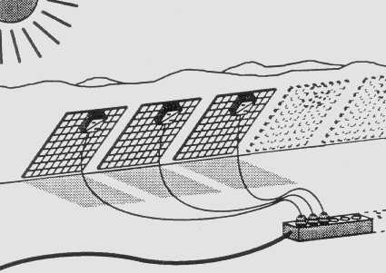
Figure 1: Representation of field operation of AC (MIC) modules by Kleinkauf in 1992 [5]

In the early nineties, we see that the promotion by Professor Kleinkauf was not in vane, since the concept was adopted by several companies, both in Europe and the USA. The different development efforts led to AC-module inverters ranging from 100 to 300 Watts, which were implemented widely during the nineties.
Examples of AC-module inverters are:
- OK4: 100 W inverter for a 72 cells PV-module (1994, Netherlands), developed by OKE, produced by NKF
- Mastervolt 130: 130 W inverter of Mastervolt for a 72 cells PV module (1994, Netherlands)
- SunSine 300: 300 W inverter of Ascension Technology for a 270 W ASE module (1996, USA)
- AES 250: 250 W transformerless inverter of SDA (Stephen Strong & Robert Wills) for a 144 cells PV module (1996, USA)
- PV2GO, 130 W inverter for a 72 cells PV-module (2000, Europe)
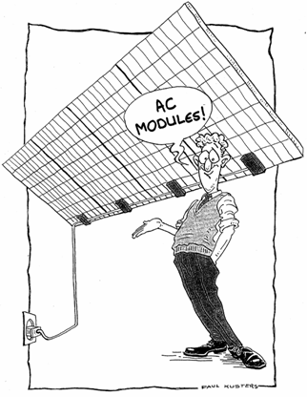
Figure 2: Representation of the AC-module approach, drawing © OKE-Services, 1994 [6]

AC-modules disappeared from the market mainly due to the (relatively) high costs and failing AC-module inverters. Recently however, we see new developments in the field of AC-module inverters, a.o.:
- MIPS, 250 W inverter for HV PV-modules (800 Vdc required) transformerless, result of EU MIPS project (2007, Europe)
- Enphase Micro-Inverter M175-24-240-S, a 175 Watt inverter (2008, USA)
- Greenray Solar (under development, 2009, USA)
- Petra Solar (under development, 2009, USA)
- Island Technology/Direct Grid Technologies, LLC (2009, USA)

3 REQUIREMENTS

To be able to compete with traditional inverters, an AC-module inverter needs to be at least “as good as” central or string inverters regarding European efficiency, safety, monitoring, installation and costs. But most importantly: preferably the reliability needs to be an order of magnitude better compared with central or string inverters.
To explain the need for the higher reliability two systems can be compared:
- A PV system with 10 AC-modules
- A PV system with the same power, but with one inverter
Further it is assumed that AC-module inverters have the same failure rate and off-time until repair as other inverters.
In that case:
- Over time the energy yield losses due to failing inverters will be the same for both systems
- But for the AC-module system, the installer may have 10 times more repairs!

In case of a large system with AC-modules, the installer can wait until the total number of failing inverters is large enough to justify the repair action. But the customer of a smaller system shall not accept that. This shows that for avoiding this increase in repairs the AC-module inverter must have a much lower failure rate than a central inverter or a string inverter.
Is that possible?

In Figure 3 the well known bathtub curve is presented, which shows the time dependence of the failure rate:
- Early failure period, also known as infant mortality period.
- Constant failure rate period: After the early failure period, the failures occur randomly over time which results in a constant failure rate during the products useful life.
- Wear-out failure period: The final period that shows an increasing rate of failures due to the dominating effects of wear-out, ageing or fatigue.

When discussing the MTBF (Mean Time Between Failures) we are talking about the constant failure rate period and when discussing lifetime or useful life we are talking about the time until the wear-out failure period starts.

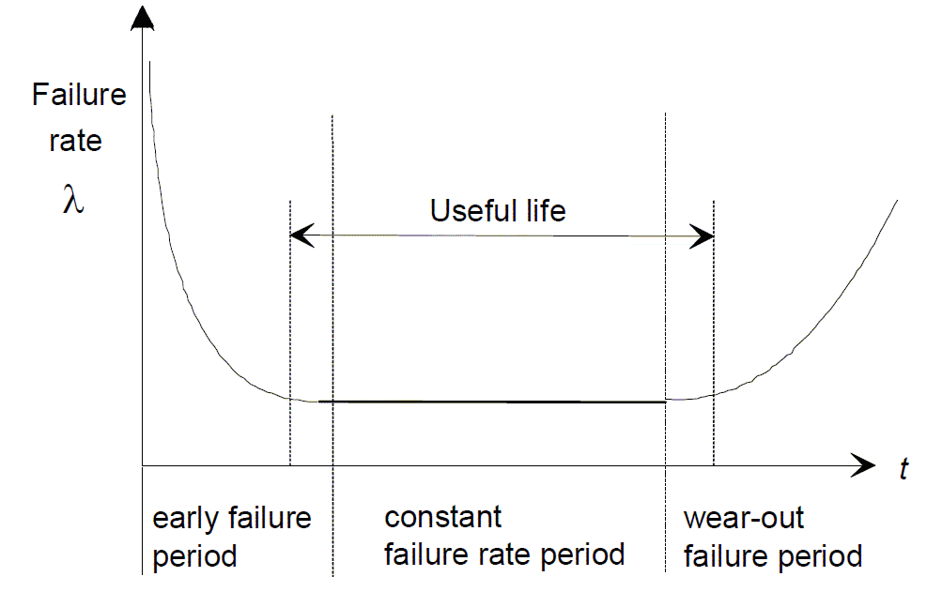
Figure 3: Time dependence of the failure rate (Source: “Guidelines to understanding reliability prediction”)

4 FAILURE RATE

During the constant failure rate period the failures occur randomly over time. A reasonable failure rate would probably be 0.1% failures per year. This implies that after 10 years 99% of the inverters are still functioning and after 50 years 95% is still working. A failure rate of 0.1% per year agrees with an MTBF of 1000 years.

The failure rate of an inverter can be estimated by the sum of the failure rates of all components. The failure rate of an electronic component is commonly expressed in Failures In Time or FIT: 1 FIT is 1 failure in 10⁹ hour = 114000 years. So for 1000 years MTBF the sum of the FIT equals 114000/1000 = 114 FIT. And, assuming 50% on time, this number increases to 228 FIT. To get the total FIT in the order of 228 is not easy.

In the SN29500 database, with reliability data of electronic components, nearly all components have 1 FIT or higher. Fortunately automotive resistors and capacitors can have 0.3 FIT. The OK4All has approximately 140 components of which 60% exists of such resistors and capacitors. This gives some margin for the rest of the components which will have a higher FIT.

Currently the total failure rate of the components of the OK4All inverter is around 320 FIT. However, most of the components are not critical and therefore minor failures in these components will not result in an inverter failure. For the critical components special types have been selected of which the stress factors are reduced by far over-rating these components.

Therefore, under the previous conditions 1000 years MTBF seems possible for the OK4All AC-module inverter.

5 USEFUL LIFETIME

There is a genuine concern about the lifetime of AC-module inverters since the AC-module inverter will be directly mounted on the PV-module. The higher ambient temperature will result in higher component temperatures for an AC-module inverter. Many articles mention the electrolytic capacitor as the weakest component in the inverter. However, these concerns can be overcome by a good thermal and mechanical design of the AC-module inverter.

Figure 4: Field measurements show the linear relation between the increase in temperature of the inverter heat sink and the increase of temperature of the cells. For the test enclosure used this is: Theatsink – Tambient = 1,25 (Tcell – Tambient)
Let’s predict the temperature distribution of the heat sink of an AC-module inverter on a worst case location: the Negev Dessert in Israel. The measured frequency distributions of ambient temperatures and cell temperature in the Negev desert in Israel during 2007 were assessed based on actual measurements.

Using the relation: Theatsink – Tambient = 1,25 (Tcell – Tambient) the annual temperature distribution of the inverter can be predicted. Field measurements (see figure 4) have shown that for a good thermal design this is realistic.

Assuming that the temperature of the electrolytic capacitor equals the temperature of the heat sink it is possible to calculate the effective ageing of the electrolytic capacitor of the inverter after one year of operation. Therefore it is assumed that degrading increases with a factor 2 for every 10 degrees increase of temperature. This means that:
1 hr @ 100 ºC = 2 hr @ 90 ºC = 4 hr @ 80 ºC = etc.

Since the lifetime of electrolytic capacitors is usually specified at 105 ºCelsius this temperature is used as reference.

The result is remarkable: even in the Negev desert the effective ageing @ 105 ºC is only 67 hours / year. For an electrolytic capacitor that would result in:
- 60 years useful life for a capacitor with 4 000 hours lifetime @ 105 ºC and
- 150 years useful life for a capacitor with 10 000 hours lifetime @ 105 ºC
The same analysis was executed with hourly data from the Netherlands (2002) resulting in lifetimes of 144 and 360 years respectively.

Conclusions:
- The useful life of the electrolytic capacitor is certainly not a limiting factor for the inverters lifetime
- Under the general agreed assumption that the electrolytic capacitor is the weakest component a 50 years useful life for an AC-module inverter seems feasible.

Figure 5: Frequency distribution of the temperature of ambient, cells, inverter heat sink and the effective ageing. Note: The effective lifetime (red) use the scale on the right.
6 FATIGUE

A final concern is the fatigue caused by the daily thermal cycle of the inverter. Based on the same method as described in the previous section it was found that in the Negev Desert the maximum daily temperature cycle of the inverter heat sink would be less than 60°C while the peak temperature would be 75°C.

Fortunately fatigue in electronic components is also a concern for the automotive industry:
- During night time the electronic circuits of a car (parked outside) will cool down to a temperature close to the temperature of an AC-module inverter
- After the engine has started – early in the morning - the temperature will rise very quickly. For under the hood electronics the temperature may rise to temperatures well above 100°C
- A basic assumption for ‘under the hood’ automotive applications is: 10 years expected life time for two thermal cycles per day with Tmax=125°C and ΔT=85°C.

For an AC-module the thermal load is one cycle per day with Tmax = 75°C and ΔT = 60°C. According to the modified Coffin-Manson equation (with Ea = 0.122 eV) the acceleration factor for automotive is a factor 4 in cycles, and since PV has only one cycle per day this equals to a factor 8 in lifetime.

Therefore we can conclude that under the previous assumptions 10 years expected life time for ‘under the hood’ electronics of a car equals 80 years expected life time for an AC-module. So a 50 years useful life for AC-module inverters is not unrealistic. Moreover, thanks to the automotive industry new components and testing methods have become available, which must be used for AC-modules as well.

7 CONCLUSIONS

In principle an AC-module inverter can meet the extreme requirements regarding reliability and lifetime, being 1000 years MTBF and 50 years lifetime.

For the OK4All inverter this has been realized by:
- the use of a minimal number of components (< 150)
- minimizing the use of components with high failure rates
- an optimized electronic and thermal design
- the use of experience and testing techniques from the automotive industry
Of course this needs to be proven. Fortunately, for AC-modules testing large numbers in the field and in the laboratory is relatively simple.

So, the AC-module inverter will certainly return and, in fact, even returns into the hands of its “father”: Professor W. Kleinkauf, who is known as:
- A big promoter of the AC-module approach in the 80’s
- Co-founder of SMA
- And still member of SMA’s Supervisory Board

OKE-Services likes to thank SMA and will give all the support needed for a successful re-introduction of the AC-module inverter.

8 REFERENCES

[1] H. Haeberlin: Damages at Bypass Diodes by Induced Voltages and Currents in PV Modules Caused by Nearby Lightning Currents, 22nd European Photovoltaic Solar Energy Conference, Milano, Italy, September 2007
[2] H. Oldenkamp et al: PV-wirefree versus conventional PV-systems: detailed analysis of difference in energy yield between series and parallel connected PV-modules, 19th European Photovoltaic Solar Energy Conference, 7-11 June 2004, Paris, France, June 2004
[3] M.A. Gross, S.O. Martin, N.M. Pearsall: Estimation of output enhancement of a partially shaded BIPV array by the use of AC modules, 26th IEEE Photovoltaic Specialists Conference, Anaheim, CA, USA, 29 September – 3 October 1997
[4] W. Kleinkauf: Photovoltaic Power Conditioning; 10th European Photovoltaic Solar Energy Conference, Lisbon, Portugal, 1991
[5] W. Kleinkauf; J. Sachau; H. Hempel: Developments in inverters for photovoltaic systems; 11th EC Photovoltaic Solar Energy Conference, Montreux, Switzerland, 1992
[6] S.W.H. de Haan, H. Oldenkamp, E.J. Wildenbeest: Test results of a 130W AC module; a modular solar ac power station, 1994 IEEE First World Conference on Photovoltaic Energy Conversion, Waikoloa, Hawaii, December 5-9, 1994
[7] The presentation together with an extensive list of references can be found on: www.oke-services.nl/OK4All.
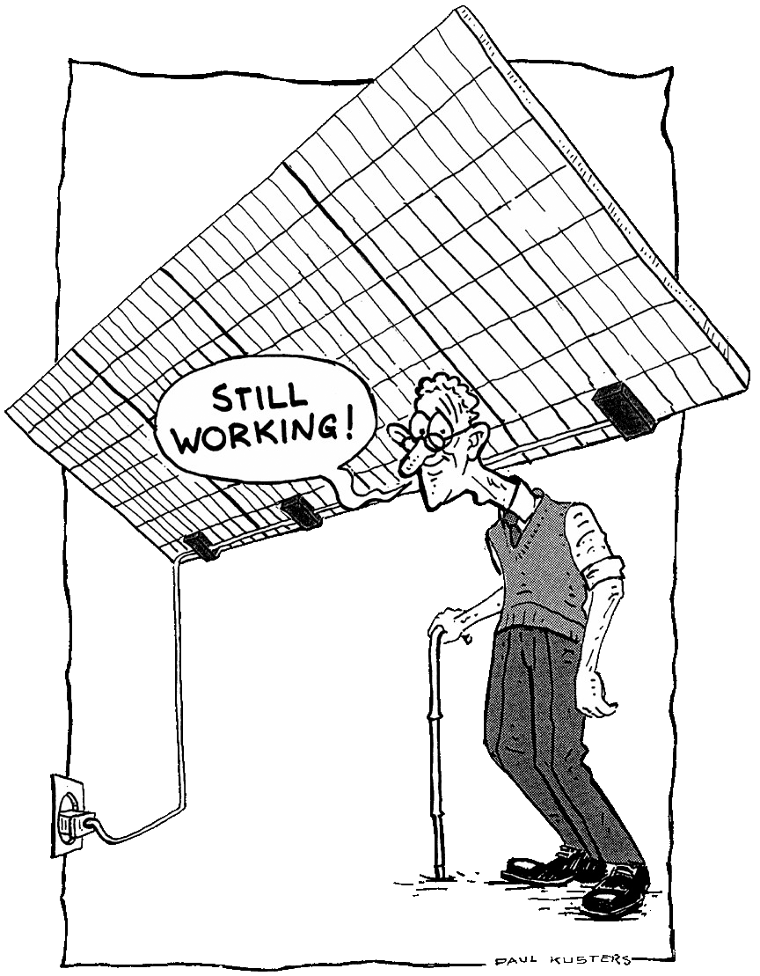
Figure 6: Representation of the AC-module approach, drawing © OKE-Services, 1995

